|  |  |
| --- | --- |
| **Name** | Ghulam Abbas Muhammad Muneeb |
| **Reg no.** | 2018-EE-361 2018-EE-359 |
| **marks** |  |

**Experiment # 04**

**Fast Decoupled Power Flow Solution by Using**

**Power World Simulator.**

**Objectives:**

* To Solve the Power flow (load flow) problem using Fast Decoupled method.
* To observe power flow analysis by using Fast Decoupled in power System.
* To model a Power System in Power Word Simulator.

**Introduction:**

In any practical power system, operating in steady state condition, there is strong interdependence between active power (P) and bus voltage angle (δ) and between reactive powers (Q) and bus voltage (V), whereas couplings between P-V and Q-δ are relatively weak. This weak-coupling effect may be neglected without introducing much inaccuracy in the load flow solution. This is known as 'decoupled load flow.

The fast decoupled power flow method is a very fast and efficient method of obtaining power flow problem solution. In this method, both, the speeds as well as the sparsity are exploited. This is actually an extension of Newton-Raphson method formulated in polar coordinates with certain approximations which result into a fast algorithm for power flow solution. This method exploits the property of the power system where in MW flow-voltage angle and MVAR flow-voltage magnitude are loosely coupled.

By using fast decoupled method, active and reactive power can be calculated by using these expression**:**

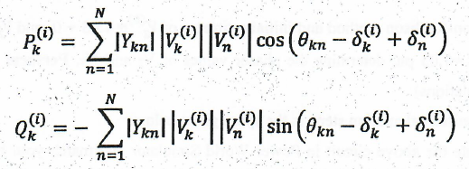

**Task #01:**

A three-bus, three-line system has been shown in Figure. Each line has series impedance of (0.02+0.1j) p.u. and shunt admittance of j0.04 p.u. in 100 MVA base. Obtain line flows, losses and bus voltages using FDLF method. Also obtain real and reactive power generation at bus-1 and reactive power generation at bus-2. (Attach the results of software simulation with this manual).

|  |  |  |  |  |  |
| --- | --- | --- | --- | --- | --- |
| **Bus no.** | **Pd** | **Qd** | **Pg** | **Qg** | **V** |
| 1 | 1 | 0.5 | - | - | 1.03+j0 |
| 2 | 1.5 | 0.75 | 0 | 0 | 1.03+j0 |
| 3 | 1 | 0.2 | 0.5 | - | 11.01 |

**Circuit diagram:**

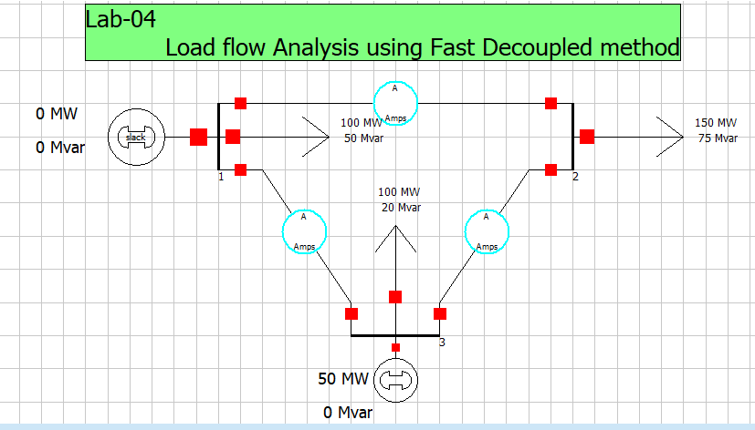**Figure 1: show the one line diagram of power system**

Using PWS

* Draw the one-line diagram in PWS.
* In the Run Mode, go to Tools →→Solve → Single Solution Fast Decoupled. This will give you the final result of the bus voltages after performing all the iterations.
* To view the mismatch vector in PWS go to Case Information → Solution Details → Mismatches. Corroborate your theoretical result with t s mismatch vector. Note you may have calculated the mismatch vector in per units out PWS displays the result in physical units. So you may need to accommodate the multiplying factor.
* To view the Jacobian matrix in PWS go to Case Information → Solution Details → Power Flow Jacobian. Corroborate your theoretical result with this Jacobian matrix.
* You can also import this Jacobian matrix into Matlab. Go to Application button and select Save Ybus or Jacobian.
* To check your results iteration by iteration, go to Tools → Simulator Options → Common Options → Check 'Do Only for One Iteration Now repeat the above step to get results for each iteration.
* While doing single iterations you will hear warning sound until the solution converges.
* The detailed results of each iteration can be viewed through log in the Tools selection.

**Software Simulation:**

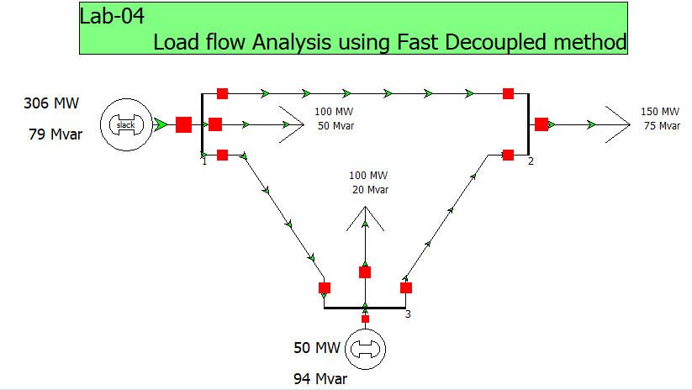**Figure 2: show the power system network simulation using gauss seidel method**

**Y-bus of given network:**

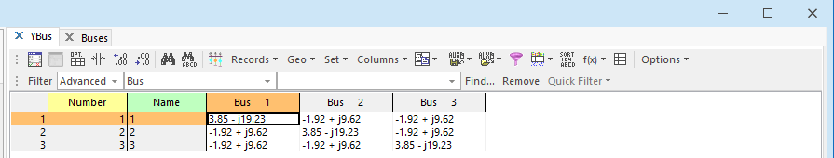

**Figure 1: Ybus Matrix**

**System Information:**

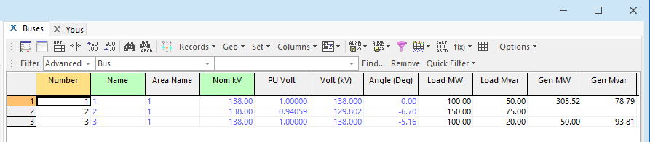

**Figure 2: Output Data of given power system network**

**Jacobian Matrix:**

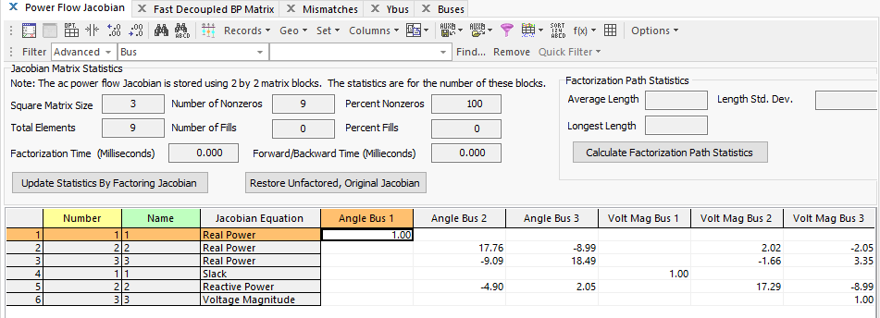**Figure 5: show the jacobian matrix of given system using fast decoupled method**

**Fast decoupled BP matrix:**

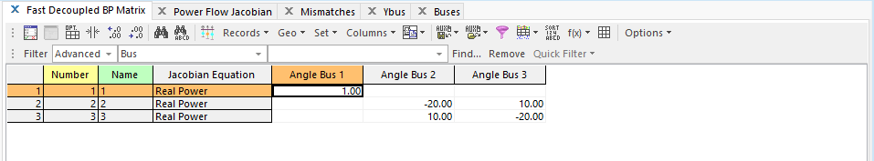**Figure 6: show the B prime matrix**

**Fast decoupled BPP matrix:**

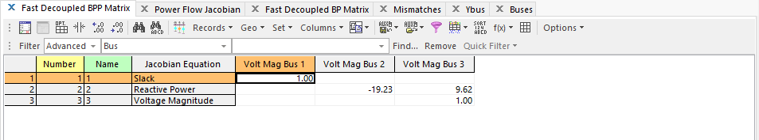**Figure 7: show the B double prime matrix**

**Conclusion:**

By using this iterative method**:**

* We learned to implement the Fast Decoupled Method in load flow Analysis.
* We observed that how fast this method be implemented and also about it’s efficiency.
* We learned to find the unknown values of voltage and Angle of load bus.
* We learned to find the unknown values of Reactive power and Angle of voltage for Generator bus.